St. Joseph’s Restorative Inquiry
Spring 2021 Newsletter

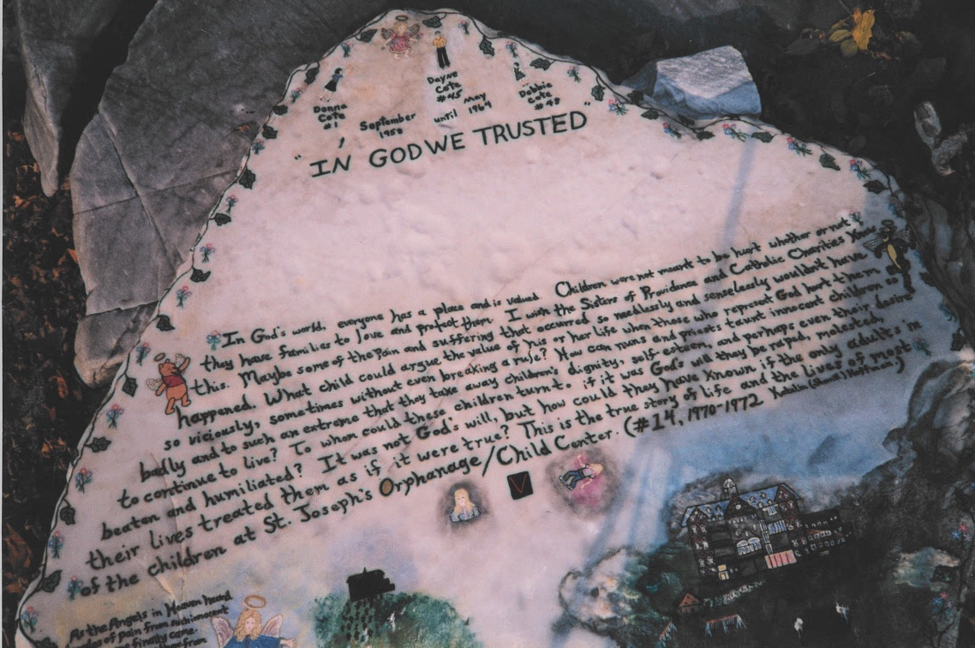
Rock on the Orphanage Beach, painted (multiple times!) by Katelin Hoffman

Overview:
This is the third newsletter from the St. Joseph’s Restorative Inquiry (SJRI). SJRI seeks to understand and document the events of the orphanage through the voices, experiences, and stories of those most impacted (former residents); and then facilitates inclusive processes of accountability, amends-making, learning, and change. Restorative Inquiry staff are committed to facilitate and respond to the group and individual priorities and requests of the former children of St. Joseph’s Orphanage.

The Restorative Inquiry is a project of the Burlington Community Justice Center. The project was launched in May of 2019 with funding and support from the Vermont Center for Crime Victim Services and is guided by an Advisory Team comprised of community stakeholders, restorative justice practitioners, and former St. Joseph’s Orphanage residents.

Restorative Inquiry participants meet every Friday from 11:00-1:00. The weekly meetings allow participants to connect with each other, share perspectives and experiences, and make decisions.
Current Initiatives:
In addition to the weekly meetings, the Restorative Inquiry is facilitating a series of initiatives that reflect the collective goals of the former residents. The following is a summary of current initiatives:
- Changing the Statute of Limitations on Physical and Psychological Abuse: In January, the group met with legislators from Chittenden County. Participants shared their experiences and impacts from the Orphanage. As a response, the legislators are using their positions to support the participants in protecting present and future children by introducing legislation to change the statute of limitations on certain kinds of abuse. This initiative may require more than one legislative session to accomplish. The group will present their testimony to the Vermont Senate Judiciary Committee the week of April 29th.
- Working with the Vermont Department of Children and Families: Participants of the Restorative Inquiry have met with representatives from the Vermont Department of Children and Families (DCF) on two occasions since January. The purpose of these meetings was for participants to share both their experiences at the Orphanage, and their “Hopes and Aspirations for Children Currently in State Care”; and for staff from DCF to present information regarding how social work practices, oversight, and policies have changed since the time of the Orphanage. The next meeting, scheduled for April, will be dedicated to brainstorming ways that Restorative Inquiry participants’ experiences can inform DCF practices and policies to ensure that no child ever again experience this nature of harms.
- Writer’s Group: In May of 2020, a group of Restorative Inquiry participants requested the opportunity to work together in a facilitated writers’ workshop. In response to this request, SJORI contracted the services of Carol Adinolfi to coordinate a series of ongoing workshops. Current written work is available on the project website. The Writer’s Group, which is currently sponsored by the UVM Medical Center, is preparing to publish a first anthology of work, which will be available for sale to the public later this Spring. New public readings are also being planned. Stay tuned!
- Orphanage Memorial: The group (and a subcommittee) are working with the City of Burlington Parks and Recreation Department to establish a public memorial to recognize the countless children who passed through and were impacted by the Orphanage. To date, the group has met with Parks and Rec staff on three occasions. These dialogues have allowed participants to share their individual visions for the memorial and for park staff to provide information about the possible locations on the former orphanage property. Parks and Rec staff will meet with the Memorial Subcommittee in April to move the project forward.
- Oral History Project: The group is partnering with the Vermont Folklife Center to record participants’ oral histories. These individualized recording sessions start in April and will take place online. Once complete, the participants will control how their recordings are shared with the public (if at all) and when their recording is made available. In addition to the full recording, which will be archived at the Vermont Folklife Center, full interviews or excerpts may also be used (with person’s permission) in exhibitions and on the St. Joseph’s Orphanage Restorative Inquiry website.
- Go Fund Me Campaign: The group has established a Go Fund Me page to support their efforts to hold institutions accountable, protect present and future children, and share their stories with the public. Donations will be passed through the City of Burlington’s Community and Economic Development Organization (CEDO). The Voices of St. Joseph’s Orphanage group will make consensus-based decisions on how the funds will be allocated to support specific goals. Every dollar that you contribute will go directly to supporting these goals: CEDO is not charging any overhead to administer this fund. Here’s the link: https://gofund.me/270a641f
Please help the group achieve their goals by making a contribution and/or sharing the campaign with others!
- Fall Gathering: The group is planning a fall reunion/gathering in Burlington, Vermont. We will have more information on the event soon, including dates and planned activities.

Other Opportunities:
- Access to Department of Children and Families Family Files: Several participants of the Restorative Inquiry were placed at the Orphanage by the State of Vermont. These participants requested the opportunity to view all state information (without redaction) related to their time at the St. Joseph’s Orphanage. In order to respond to this request, the Department of Children and Families (DCF) collaborated with SJORI staff to first search state archives, and then share found records with the corresponding participants. If you are a former resident and are interested in learning if the State of Vermont found your family records, please contact Marc Wennberg.
- Medical Records: SJORI staff partnered with UVM Medical Center to search for any available medical records of participants from their time at the Orphanage. UVM Medical Center has distributed found records to corresponding participants. If you are a former resident and are interested in learning if the UVM Medical Center has any relevant medical records, please contact Marc Wennberg.

How to get involved:
- If you are a former resident of St. Joseph’s Orphanage and would like to participate in the Restorative Inquiry, please contact Marc Wennberg at: marc@communityreentry.net or by calling 802-522-7394.
- If you are a former resident of St. Joseph’s Orphanage and in need of support, you can connect with Amy Farr, Victim Advocate at the Vermont Attorney General’s Office at amy.farr@vermont.gov or at 802-279-1027.
- All other requests and questions can be directed to Marc Wennberg at: marc@communityreentry.net.

